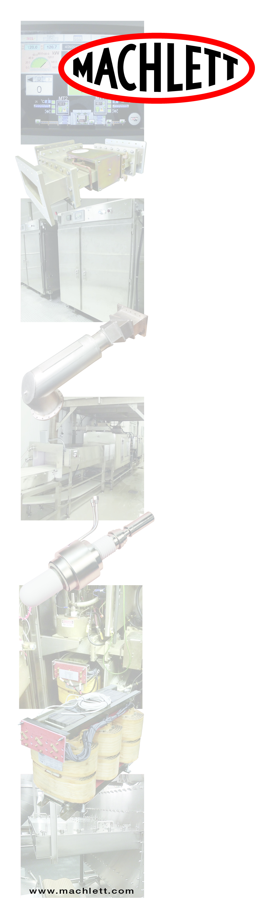

**REASONS FOR TEMPERING**

THINK MACHWAVE MICROWAVE TEMPERING

* Machlett microwave tempering lines can temper in minutes with no drip loss or bacterial growth. Conventional methods take time, handling, and require careful monitoring due to bacteria and HACCP concerns.
* Next time you think about tempering any type of product such as: BEEF, PORK, CHICKEN, SEAFOOD, FISH, FRUITS, VEGETABLES
* Machlett microwave tempering systems are the system of choice for some of the largest companies worldwide.
* They provide for point of product temperature control and help in the control of bacteria such as E-Coli and listeria from incubating and contaminating your product.
* Drip loss saving of 5%-10% will provide a one-year payback.
* No longer do you have to worry about cold centers.
* Machwave circular feed technology provides excellent uniformity throughout the product.

* The results are higher yields, improved quality, and for a given footprint, much higher throughput.
* Yields and quality will be enhanced due to speed of tempering.

**Penta Labs/Machlett Microwave** 9740 Cozycroft Ave., Chatsworth, CA 91311 Office: 800-421-4219 ext. 205

**Industrial Microwave**

**Systems & Service**

